computational Assigment #6

Brandon Moretz

### computation

* 1. *For the STRESS variable, make a histogram and obtain summary statistics.*

Min. 1st Qu. Median Mean 3rd Qu. Max.

**0.00 0.00 1.00 1.73 3.00 9.00**

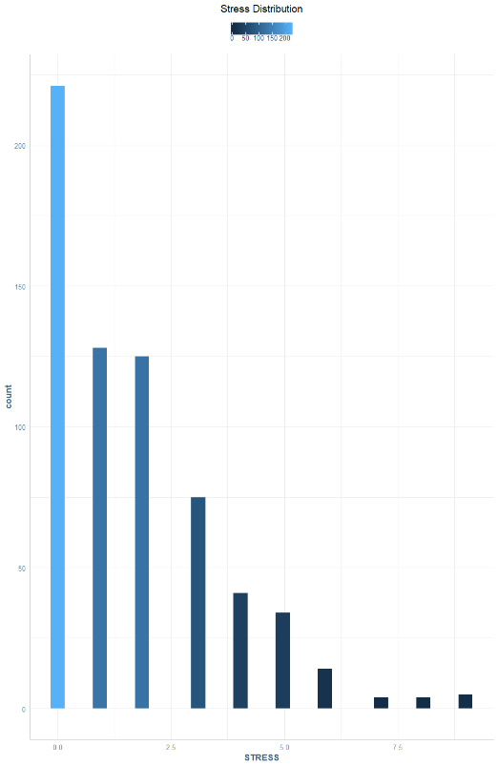

* 1. *Obtain a normal probability (Q-Q) plot for the STRESS variable.*

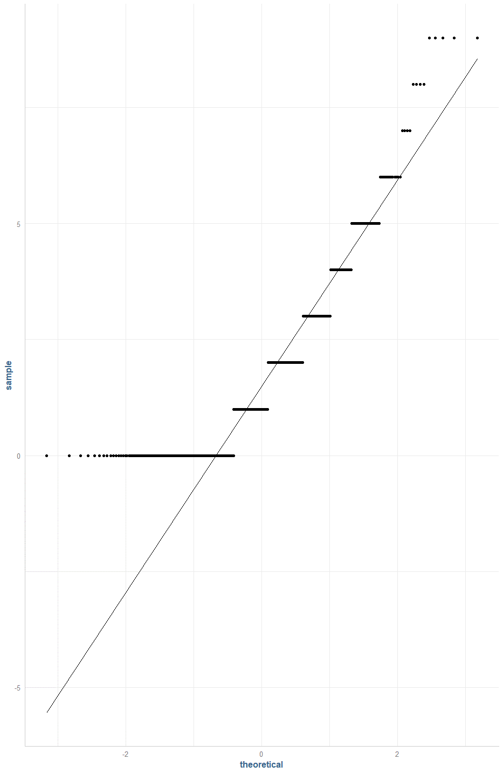

* 1. *Is STRESS a normally distributed variable?*

Stress is not a normally distributed variable, it has a heavy right skew.

* 1. *What do you think is its most likely probability distribution for STRESS?*

STRESS looks like it follows a Poisson distribution, which we can see from the below graphical comparison:

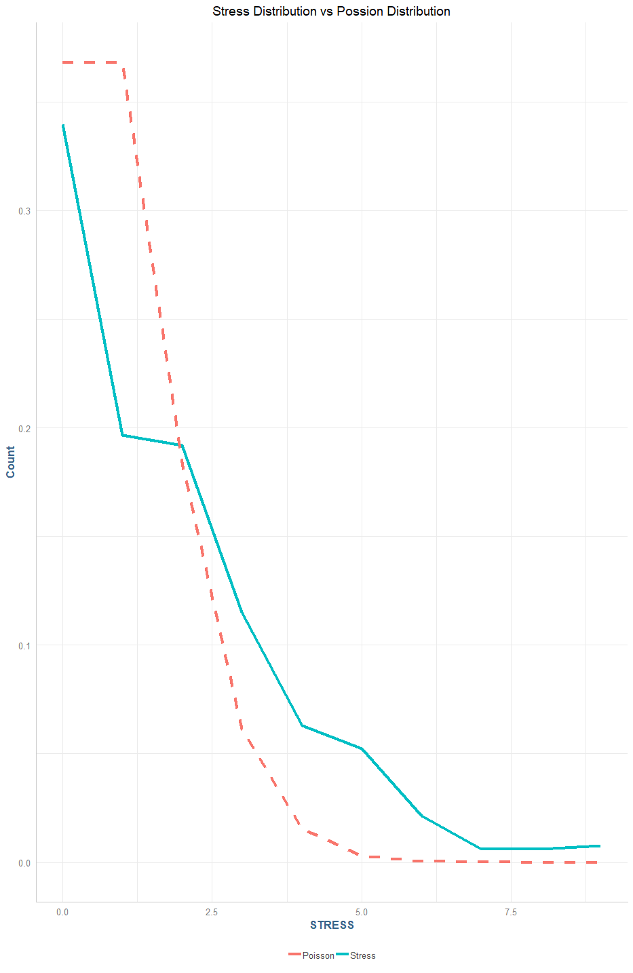

* 1. *Give a justification for the distribution you selected.*

The distribution of the stress variable follows a Poisson distribution with a heavy right tail that slowly tappers off in the end. We can see the comparison of the actual values of stress in blue vs a Poisson distribution in the red dotted line.

* 1. *Fit an OLS regression model to predict* ***STRESS (Y)*** *using* ***COHES****,* ***ESTEEM****,* ***GRADES****,* ***SATTACH*** *as explanatory variables (X).*

Model 1

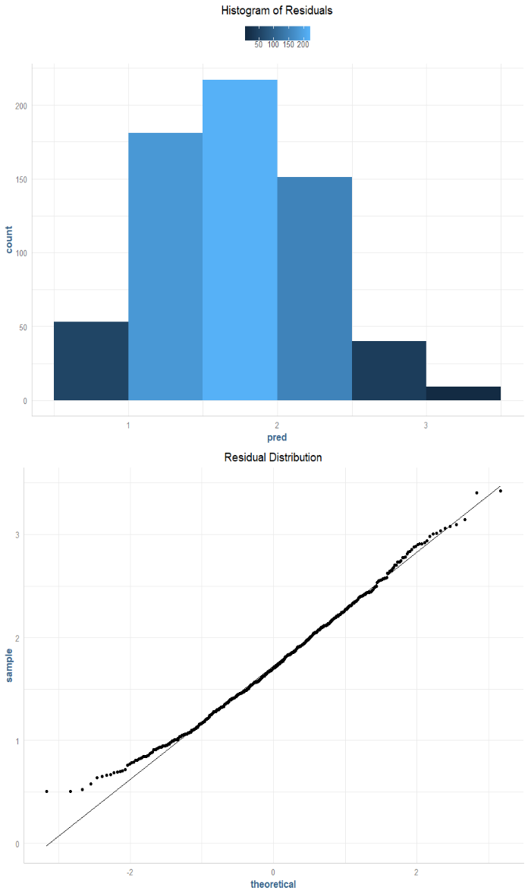ŷ = 5.713 – 0.023β1 – 0.412β2 – 0.0471β3 – 0.03β4

In the model, the intercept term of 5.713 would denote the mean stress level when all the coefficients are zero. Where β1 is COHES, a measurement of how well an adolescent gets along with their family. A one unit increase here denotes a 0.023 unit decrease in stress. Esteem is represented by β2, and a one unit increase here represents a 0.412 decrease in an individual’s stress. Grades is the sum of the grades for the prior year and are represented with the β3 coefficient, where a one-unit increase represents a 0.0471 decrease to an individual’s stress. Finally, we have SATTACH which is a measurement of how well a student is attached to their school, and a one unit increase here would represent a 0.03 unit decrease in an individual’s predicted stress.

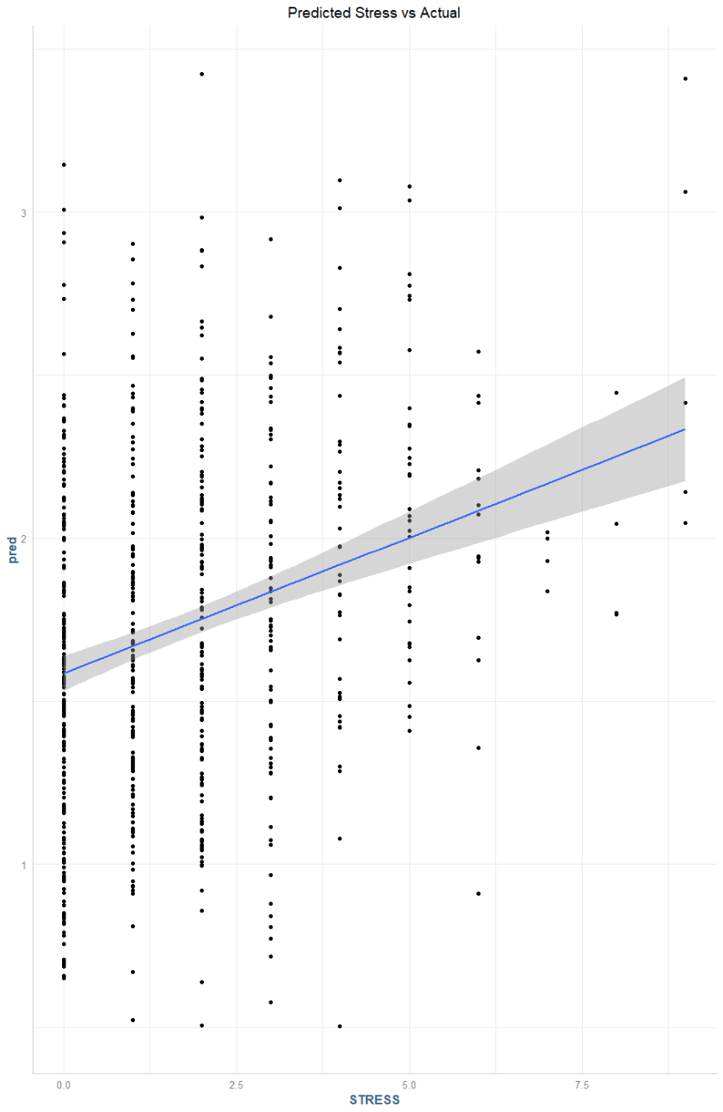The fitted model has an R2 of **.0831**, which denotes it explains approximately **8**% of the variance in the data, which does not denote a good fit for the data. The residuals are approximately normally distributed as we can see in the chart to the left.

* 1. *Obtain the typical diagnostic information and graphs. Discuss how well this model fits. Obtain predicted values (****Y_hat****) and plot them in a histogram. What issues do you see?*

The distribution of the residuals is approximately normal, which is fine, however, if we look at a plot of the predicted values of stress () vs the actuals and fit a linear model over this data set, we can clearly see there are several issues with using this model to infer an individual’s stress.

* 1. *Create a transformed variable on Y that is* ***LN****(Y).*
  2. *Fit an OLS regression model to predict* ***LN****(Y) using* ***COHES****,* ***ESTEEM****,* ***GRADES****,* ***SATTACH*** *as explanatory variables (X).*
  3. *Obtain the typical diagnostic information and graphs. Discuss how well this model fits. Obtain predicted values (****LN****(Y)_hat) and plot them in a histogram.*
  4. *What issues do you see? Does this correct the issue?*

1. *Use the glm() function to fit a Poisson Regression for STRESS (Y) using COHES, ESTEEM, GRADES, SATTACH as explanatory variables (X). Interpret the model’s coefficients and discuss how this model’s results compare to your answer for part 3). Similarly, fit an over-dispersed Poisson regression model using the same set of variables. How do these models compare?*
2. *Based on the Poisson model in part 4), compute the predicted count of* ***STRESS*** *for those whose levels of family cohesion are less than one standard deviation below the mean (call this the low group), between one standard deviation below and one standard deviation above the mean (call this the middle group), and more than one standard deviation above the mean (high). What is the expected percent difference in the number of stressful events for those at high and low levels of family cohesion?*
3. *Compute the AICs and BICs from the Poisson Regression and the over-dispersed Poisson regression models from part 4). Is one better than the other?*
4. *Using the Poisson regression model from part 4), plot the deviance residuals by the predicted values. Discuss what this plot indicates about the regression model.*
5. *Create a new indicator variable (Y_IND) of* ***STRESS*** *that takes on a value of 0 if* ***STRESS****=0 and 1 if* ***STRESS****>0. This variable essentially measures is stress present, yes or no. Fit a logistic regression model to predict Y_IND using the variables using* ***COHES****,* ***ESTEEM****,* ***GRADES****,* ***SATTACH*** *as explanatory variables (X). Report the model, interpret the coefficients, obtain statistical information on goodness of fit, and discuss how well this model fits. Should you rerun the logistic regression analysis? If so, what should you do next?*

### Research

***9.)*** *It may be that there are two (or more) process at work that are overlapped and generating the distributions of* ***STRESS****(Y). What do you think those processes might be? To conduct a ZIP regression model by hand, fit a Logistic Regression model to predict if stress is present (Y_IND), and then use a Poisson Regression model to predict the number of stressful events (****STRESS****) conditioning on stress being present. Is it reasonable to use such a model? Combine the two fitted model to predict* ***STRESS*** *(Y). Obtained predicted values and residuals. How well does this model fit? HINT: You must be thoughtful about this. It is not as straight forward as plug and chug!*

### Conclusion

***10.)*** *Use the pscl package and the zeroinfl() function to Fit a ZIP model to predict STRESS(Y). You should do this twice, first using the same predictor variable for both parts of the ZIP model. Second, finding the best fitting model. Report the results and goodness of fit measures. Synthesize your findings across all of these models, to reflect on what you think would be a good modeling approach for this data.*